SAFE WORK PRACTICES FOR

Guidelines for Helicopter Lift Operations

Any proposed usage of helicopters by a contractor to hoist, set, install, or move equipment or materials on NGAS SP property shall conform to the following guidelines.

Helicopter Operations

- Prior to an anticipated helicopter lift operation, a thorough survey of the conditions and hazards on the job site shall be made by the contractor, the helicopter pilot (or pilot’s representative), and the NGAS SSD company representative to ensure a safe operation.

- The NGAS company representative shall request the contractor to provide a written work plan of the lift operation, and a copy shall be submitted to ESH&M for review at least two days prior to the lift. Information to be provided in the work plan shall include:

- location of the lift
- anticipated work dates
- detailed description of the work to be performed
- any required notification/coordination of company personnel or security, local agencies (e.g., police or fire) or adjacent property owners for the purpose of restricting work area access
- any safety hazard control measures that may be required (e.g., barricades around work area)
- appropriate emergency procedures (e.g., location of an emergency landing site)

- The helicopter contractor shall have a “Code of Safe Practices” formulated in compliance with Title 8, California Code of Regulations, Article 35: Helicopter Operations that shall be enforced for all helicopter lift operations. The contractor’s “Code of Safe Practices” for helicopter lift operations shall be provided to EHS as an attachment to the written work plan.

- Helicopter lift operations shall comply with any applicable regulations of the Federal Aviation Administration (FAA). The NGAS SSD company representative shall ensure the pilot and the helicopter are properly certificated by the FAA for external load operations and that a Congested Area Plan for the lift operation has been submitted to and approved by the FAA. The local FAA office for Redondo Beach and Carson area is located in Long Beach. To contact an Operations Inspector at the Long Beach office dial (562) 420-1755. The local FAA office for Manhattan Beach is located at LAX. To contact an Operations Inspector at the LAX office dial (310) 215-2150.

- The NGAS SSD company representative shall conduct a briefing prior to the anticipated lift to communicate the operational plan. This briefing shall include a review of the contractor’s work plan and methods for minimizing possible hazards of the operation. All personnel exposed to lift operations shall be informed and directed as to the appropriate safeguards and escape procedures.

- Building occupants and NGAS SSD Security shall be notified at least 24 hours in advance of any planned lift operation. NGAS SSD Security shall assist with the evacuation of building occupants to ensure that unauthorized persons do not remain in, or have access to, the operational work area as defined in the contractor’s work plan (i.e., the staging area, the equipment pick-up area, the proposed flight path, and load drop zone).

- Helicopter operations shall not be performed beyond the helicopter’s approved external load capacity or pilot’s certification. Helicopter operations shall not be performed under adverse weather conditions, e.g., gusty wind conditions greater than 15 knots.

General Safety Rules

- If the helicopter pilot in command for any reason believes that a lift or operation cannot be performed safely, then that lift or operation shall not be attempted.

- Landing and hovering sites shall be chosen with approval of the pilot or pilot's representative and the NGAS SSD company representative. All such sites shall have at least a 200-foot diameter area clear of all loose materials and objects that could be hazardous if displaced by rotor downwash. The helicopter shall be required to deposit or lift loads in the center of the approved area.

- Signal systems between the air crew and ground personnel shall be understood and checked in advance of hoisting the load. Hand signals shall be as shown in Figure 1. The pilot shall receivesignals from only one signal person who is distinguishable from the rest of the crew.

- All ground crewmembers shall be thoroughly instructed by the pilot or pilot’s representative in their duties and of the immediate hazards. Escape procedures shall be planned with the pilot or pilot's representative in event of helicopter failure.

- Ground crewmembers shall wear dust goggles for eye protection and approved head protection with chin straps in place. Ear protection and dust protection shall be used when required.

- Only those persons associated with the helicopter operations shall be permitted to approach within 50 feet of the operating helicopter. An effective method of protecting workers from static electrical discharge shall be provided.

- All cargo shall be loaded and secured under the direction of the pilot or pilot's designee.
- All sling loads, including line stringing devices, shall be attached only to quick-release devices. Tag lines shall be of a length or secured in such a manner so as to prevent their being drawn up into the rotors. The pilot shall approve tag line quantity, placement, and length.

- There shall be a minimum clearance of at least 25 feet between any energized power line, rated 50 KV or below, and any part of the rotorcraft load combination. This clearance requirement shall increase at the rate of 1/2 inch for each 1 KV.

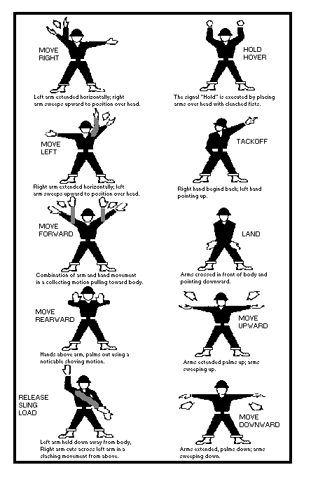
Figure 1 - Helicopter Hand Signals

