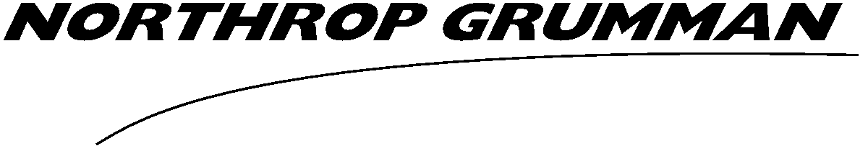  DoD SECURITY CLEARANCE REQUEST  Form C-834 (3-11)* Page 1 of 2 | NORTHROP GRUMMAN  PRIVATE/PROPRIETARY - LEVEL I  (WHEN COMPLETED)

THIS FORM MUST BE FILLED OUT COMPLETELY TO PREVENT RETURN OR DELAY. For faster service, if you have access to the Northrop Grumman Global Network, enter data .

APPLICANT STATUS
Current employee New hire* Professional Service Provider Consultant | * START DATE
HAS , DoD SECURITY CLEARANCE CITIZENSHIP CONFIRMATION, BEEN COMPLETED
YES NOT REQUIRED

APPLICANT PERSONAL INFORMATION
LAST NAME | FIRST NAME |  | MI | MyID NO.
NORTHROP GRUMMAN EMAIL ADDRESS (IF ANY) |  | OTHER EMAIL ADDRESS (IF A COMPANY ADDRESS NOT YET ESTABLISHED)

CLEARANCE INFORMATION
CLASSIFIED CONTRACT NO. ON WHICH THE APPLICANT IS TO WORK |  |  | CLEARANCE LEVEL REQUESTED  TOP SECRET SECRET CONFIDENTIAL
CAGE CODE (CONTACT YOUR FACILITY SECURITY OFFICER) |  |  | COMPANY ELEMENT  CORPORATE AS ES IS TS
DESCRIPTION OR NATURE OF THE APPLICANT’S JOB REQUIRING CLASSIFIED ACCESS

DOES THE APPLICANT HAVE A CURRENT CLEARANCE  YES NO |  | IF YES, CURRENT CLEARANCE WITH  DoD ANOTHER AGENCY* |  | *IDENTIFY IF NON-DoD CLEARING AGENCY
DOES THE CUSTOMER ON THE CLASSIFIED CONTRACT IDENTIFIED ABOVE REQUIRE CLEARANCE ADJUDICATION, VERSUS NORMAL ADJUDICATION BY DISCO
YES NO
IF YES, WHAT IS THE SPECIAL ADJUDICATING AGENCY
UNCLASSIFIED: CLASSIFIED (DO NOT LIST HERE)
REQUESTING MANAGER NAME | MyID NO. |  | EMAIL ADDRESS

DoD SECURITY CLEARANCE REQUEST  Form C-834 (3-11)* Page 2 of 2 | NORTHROP GRUMMAN  PRIVATE/PROPRIETARY - LEVEL I  (WHEN COMPLETED)
INSTRUCTIONS
APPLICANT STATUS | Select one and enter the projected start date if a new hire.
APPLICANT NAME | Enter last and first name and middle initial.
MyID NO. | Enter the applicant’s six-character MyID number.
EMAIL ADDRESS(ES) | Enter at least one email address where the applicant may currently be contacted regarding clearance processing.
NO. OF CLASSIFIED CONTRACT | Enter the number of the classified contract(s) on which the applicant will be working, and for which clearance is required.
LEVEL OF CLEARANCE | Select one. The clearance level requested may not be higher than the level of the classified contract identified, and should not be higher than the level of classified information on which the applicant will work.
COMPANY ELEMENT | Select the company element to which the applicant and requester belong.
DESCRIPTION OR NATURE OF THE APPLICANT’S JOB REQUIRING CLASSIFIED ACCESS | Enter a short description of the job duties of this individual that requires the individual to have access to classified materials in the performance of their job duties.
REQUESTING MANAGER NAME | Enter the name of the requesting manager.
MyID NO. | Enter requesting manager’s six-character MyID number.
EMAIL ADDRESS | Enter requesting manager’s Northrop Grumman email address.
DOES THE APPLICANT HAVE A CURRENT CLEARANCE | Make the proper selection.
CURRENT CLEARANCE WITH | Make the proper selection.
IDENTIFY THE CLEARING AGENCY | If not DoD, identify the agency holding the current clearance.
DOES THE CUSTOMER REQUIRE CLEARANCE ADJUDICATION, VERSUS NORMAL ADJUDICATION BY DISCO | Select one. Most DoD clearances are adjudicated by DISCO but some special customers require that they adjudicate the clearance eligibility rather than DISCO.
SPECIAL ADJUDICATING AGENCY | Select whether classified or unclassified agency identity. If UNclassified, identify the adjudicating agency. DO NOT ENTER CLASSIFIED INFORMATION.
REQUESTING MANAGER NAME | Enter the name of the requesting manager.
MyID NO. | Enter requesting manager’s six-character MyID number.
EMAIL ADDRESS | Enter requesting manager’s Northrop Grumman email address.

